HTML
- Head: html info (title for example)
- body: html description → need to be discussed

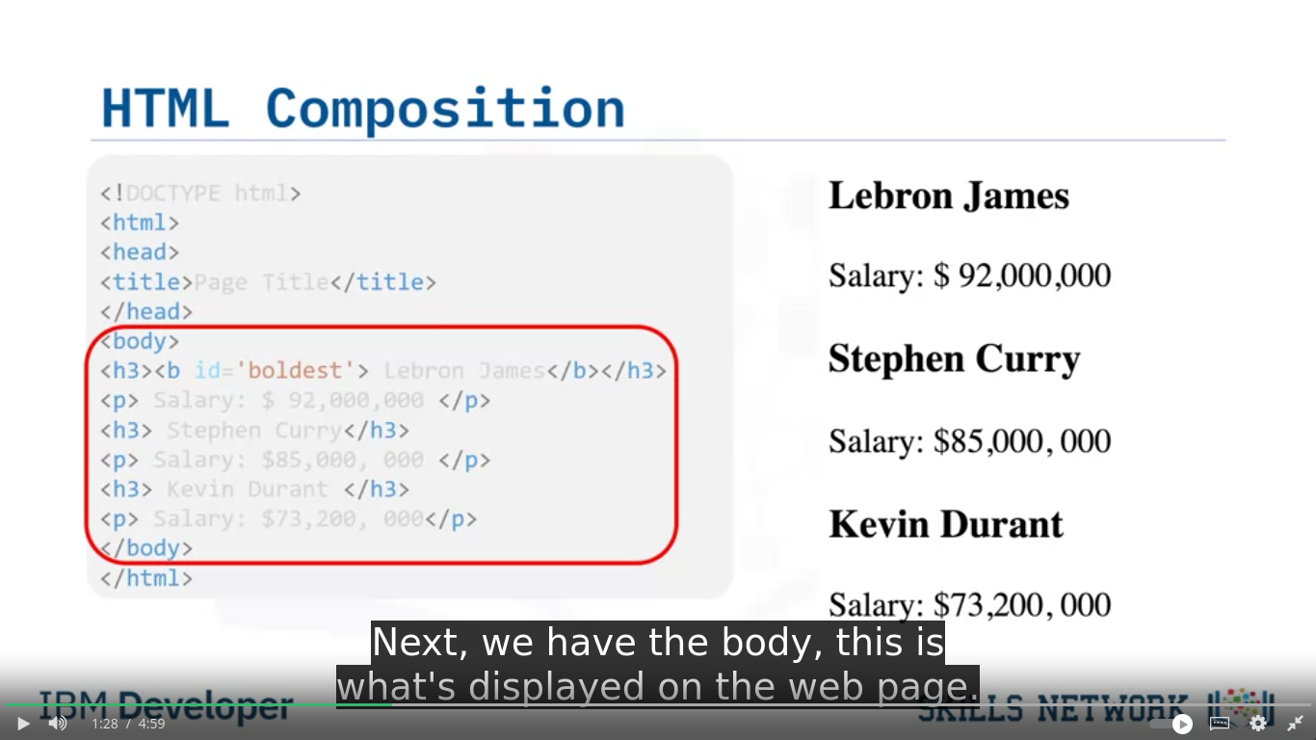
.
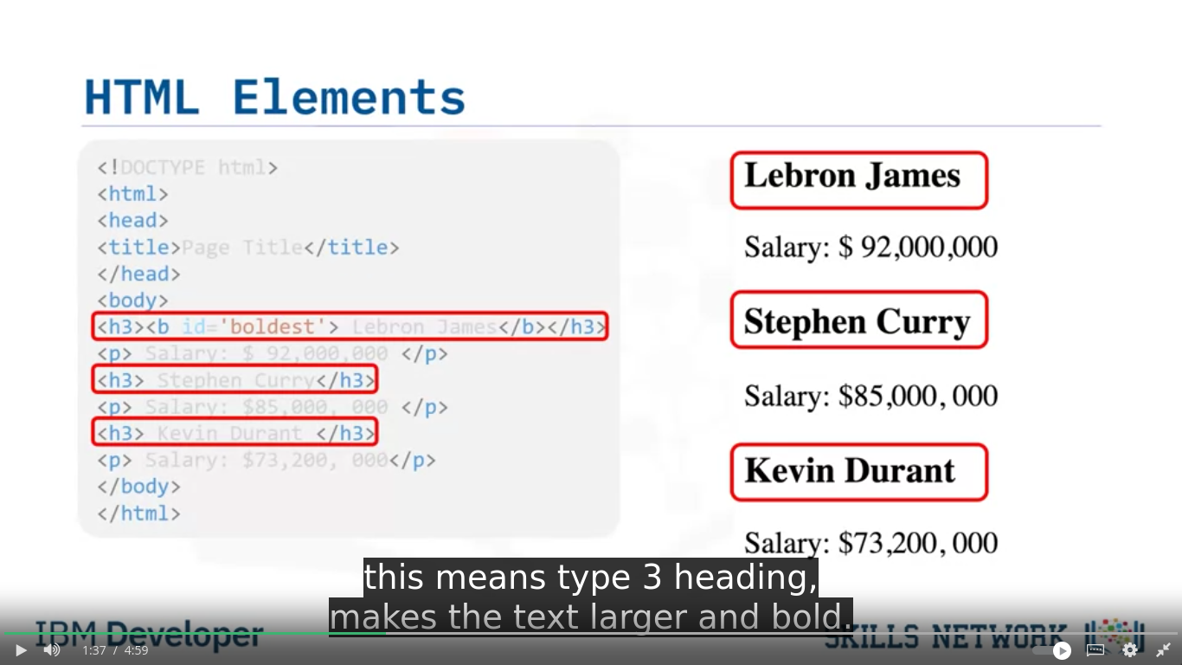
.

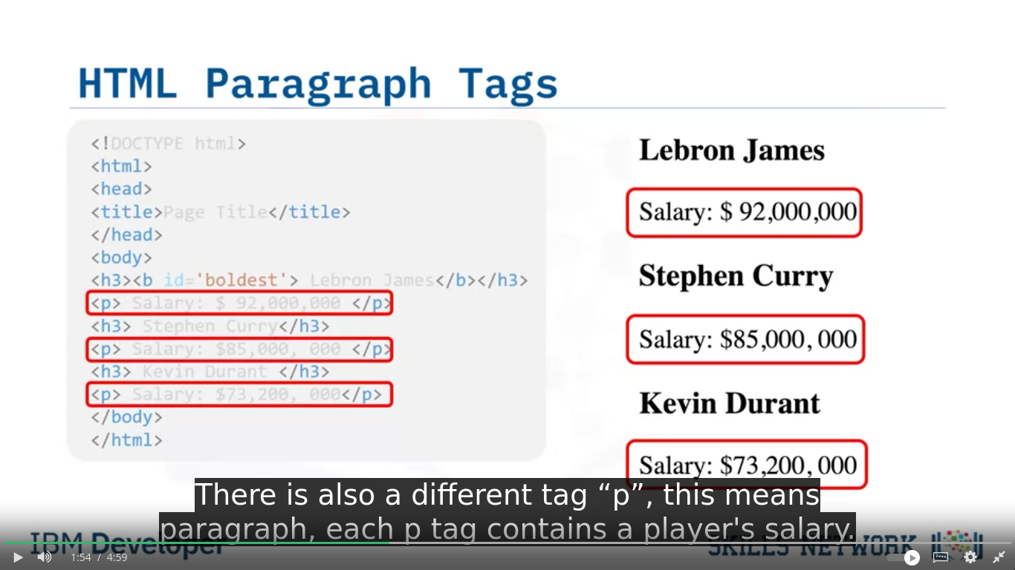
.
h3 → heading 3
p → paragraph

HTML TAG COMPOSITION
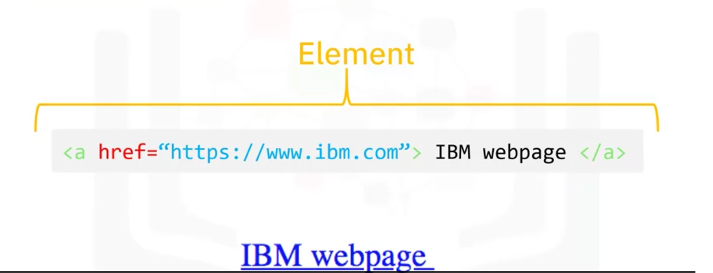
.
Tag name
Start tag
End tag
Attribute name=’attribute_value’
ATTRIBUTE

Document Tree → parent, children, siblings
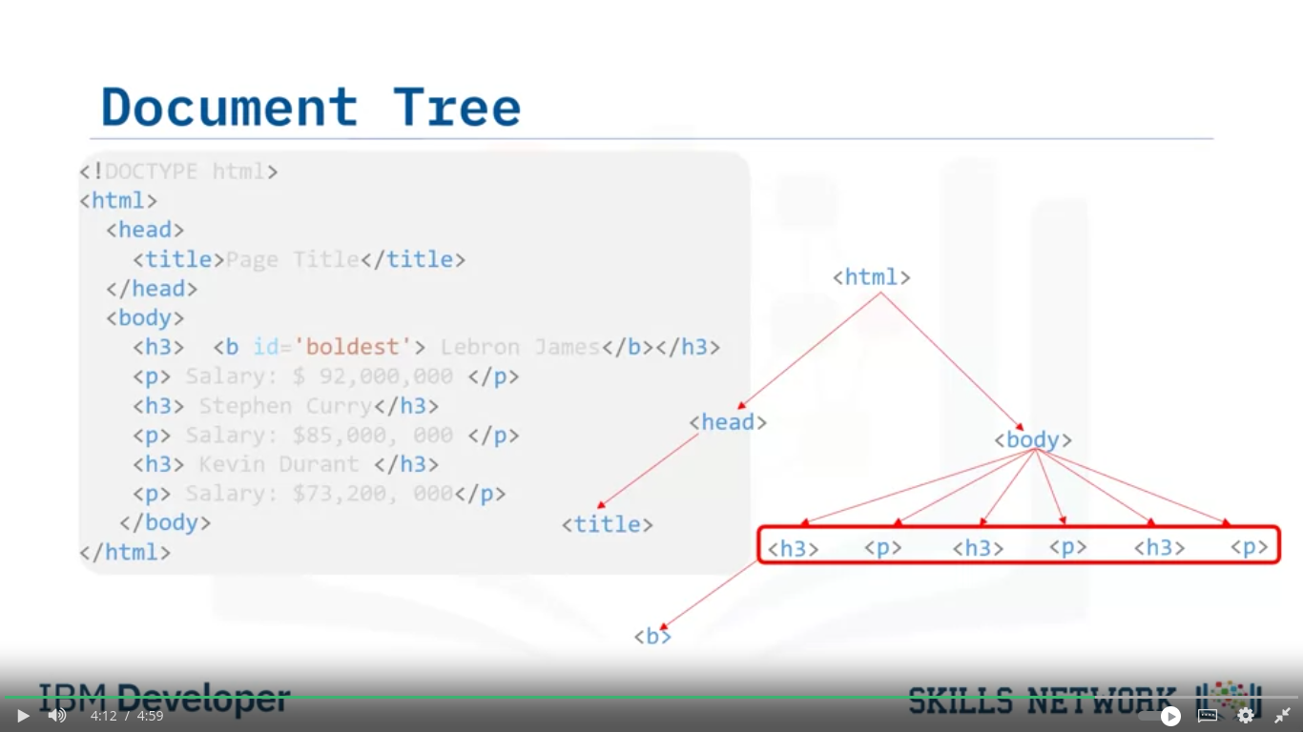

HTML Tables
